

|  |
| --- |
| Palant Word Template  Simplifiyng work of creator  By Палихов Антон  Version 0.3 | Release date: 09.07.2020 |

Palant Word Template

Palant Word Template

Палихов Антон

Credits

|  |
| --- |
| A Note from the Designer  Thanks so much for downloading this template! If you have any questions, feedback, or suggestions for features you’d like to see, please get in touch! You can reach me on Twitter [@laura_hirsb](https://twitter.com/laura_hirsb) or email [Lhirsb@gmail.com](mailto:Lhirsb@gmail.com?subject=5e%20Word%20Template).  If this template helped you, I’d be thrilled for you to share about it on social media, or leave a review on the product page so others can hear about your experience!  When you publish your product, please include a credit indicating you used my template, along with a link (I’ve already provided a sample in the credits to left). This helps others learn about this product and support my work.  Cheers,  Laura Hirsbrunner  P.S. If ever you have a particularly fun project in need of editing—I’m a professional copyeditor and platinum-bestselling game designer. I’d love if you reached out! |

All other original material in this work is copyright 2020 by  and published under the Community Content Agreement for Dungeon Masters Guild.

Only one Designer: Anton Palikhov

Editing: no one

Template: This document was created with Palant Word Template by Anton Palikhov

Testers: none

Inspired by:  [Simple 5E Microsoft Word Template & Beginner's Guide](https://www.dmsguild.com/product/311458/Simple-5E-Microsoft-Word-Template--Beginners-Guide?affiliate_id=759617) by [Laura Hirsbrunner](https://www.dmsguild.com/browse.php?author=Laura%20Hirsbrunner), [InDesign Templates and Beginner's Guide](https://www.dmsguild.com/product/249157/InDesign-Templates-and-Beginners-Guide?affiliate_id=759617) by [Nathanael Roux](https://www.dmsguild.com/browse.php?author=Nathana%C3%ABl%20Roux)

About us

Cyborgs&Mages is Russian speaking RPG Community which unites players and Dungeon Masters from Belarus, Russia and Ukraine.

[](https://www.facebook.com/Cyborgs-and-Mages-101450734568540) | [](https://vk.com/cyborgsandmages) | [](https://cyborgsandmages.wordpress.com/) | [Discord](https://discord.gg/xRCsKBQ)

Disclaimer. Титианическая рвботв.

|  |
| --- |
| Tip: Update the Copyright Info Below!  You can use the copyright info at the bottom of this page for your own document. However, be sure to replace my name (Laura Hirsbrunner) with your own before publishing! |

Table of Contents

Credits 1

ABOUT US 1

Introduction 3

Examples of Styles 4

Title page 4

Paragraph Styles 4

Headings 4

Chapter Title ToC 4

Heading 1 ToC 4

Heading 2 ToC 4

Heading 3 ToC 4

Subchapter Title 4

ToC Style 1 4

ToC Style 2 4

Chapter Title 4

Playtest Heading 1 5

Basic 5

Core 5

List 6

Epigraphs & Cites 6

Tables 6

Sidebars 6

Other 6

DD 6

Other 7

Character styles 7

Colored character styles 7

Special 7

Monster Stat Block 7

Monster Name 8

CCC Stat Block Title 8

Colors & Fonts 9

Parameters of Formatting 12

Using this Template 13

Open styles gallery 13

Applying styles 14

Use paragraph styles to bold/italicize 14

Page margins 14

Creating Drop Cap 15

Using Images 16

Inserting Art 16

Positioning Your Image 16

Image Effects 16

Picture Styles 16

Artistic Effects 16

Hotkeys 17

Miscellaneous FAQ 18

Stat blocks 19

Character Name 21

Example of filled universal stat block – player character 21

Example of filled universal stat block – generic NPC 21

Example of filled universal stat block – standard monster 21

Monster Name 22

Monster Name 22

Flaming Fist Battle Wizard 23

Monster Name 23

[Stat Block Heading 24](https://d.docs.live.net/4050d6280c872bd7/TRPG/ZZ_TOOLS/0_DEVELOPMENT/0000_TEMPLATE/TEMPLATE%20EDITING%20V03%20.docx#_Toc47528878)

[Stat Block Heading 25](https://d.docs.live.net/4050d6280c872bd7/TRPG/ZZ_TOOLS/0_DEVELOPMENT/0000_TEMPLATE/TEMPLATE%20EDITING%20V03%20.docx#_Toc47528879)

[Legendary Actions 25](https://d.docs.live.net/4050d6280c872bd7/TRPG/ZZ_TOOLS/0_DEVELOPMENT/0000_TEMPLATE/TEMPLATE%20EDITING%20V03%20.docx#_Toc47528880)

Sidebars samples 28

Tables samples 32

Spellcasting 33

Spellcasting Ability 33

Bonus Spells 33

Sample Spells Table 33

Other Blocks 39

Двуязычность 40

USEFUL LINKS 41

CHANGELOG 41

LEGAL 42

44

Introduction

From Author

I was inspired to create this template by amazing works of Laura and Nat.

If you want to use complete simple and not complex Word template – I Can recommend to use Laura’s.

My template, from other side, has:

* More styles
* Hotkeys to applying them
* Additional samples of tables, sidebars and other elements.
* Different variation of Statblocks

Styles.

Colors & Fonts

Using this Template

Hotkeys

Parameters of Formatting

Statblocks

Sidebars

Tables

Other Blocks

Useful Links

Changelog

Examples of Styles

Epigraph. Used for epigraphs and vignettes. Don’t enclose the epigraph with quotes. If an attribution is included, format it as follows.

Epigraph 2

—Author, Source

Title page

|  |
| --- |
| Author  Used for the Author name on the cover  Title  Title Subtitle |

Book Title

Book Subtitle

Book Code

Book Designer

Book adventure Level

Book author Name

|  |
| --- |
| Book Back Title  Book Back Text  Book Tagline |

Paragraph Styles

Headings

Chapter Title ToC

Used for Chapter Titles you want to show up in the Table of Contents.

Heading 1 ToC

Same as Heading 1 but used for paragraph names you want to show up in the Table of Contents, like Primal Paths or Bard Colleges in the PHB.

Heading 2 ToC

Same as Heading 2 but used for paragraph name you want to show up in the Table of Contents, like a subclass name for example.

Heading 3 ToC

Heading 4 ToC

Heading 5 ToC

Subchapter Title

Use Subchapter Title only for mini-chapters, such as the class sections in the Player’s Handbook. In most cases, you should be using Heading 1 ToC instead.

Headline 1

Headline 2

Headline 3

Headline 4

Headline 5

ToC Header

ToC Style 1

Used for main entries into the ToC, pairs up with Chapter Title ToC

ToC Style 2

Used for secondary entries into the ToC, pairs up with Heading 1 ToC

Toc Style 3

Used for tertiary entries into the ToC, pairs up with Heading 2 ToC

Chapter Title

Used for Chapter Titles.

Playtest Heading 1

Playtest Heading 2

Playtest Heading 3

Basic

Basic Text Paragraph 1

Basic Text

The default paragraph style to use. This is the foundational style—the one used for most of the body of the books.

Basit Text Hanging

This is a hanging indent; these are generally used for lists of items. To make the section before the colon bold, highlight it then assign the “CHAR BOLD” style. For an example of this in practice, check out the PHB’s section on Dwarf Names.

Good for Spell Info: You can also use this style for things like spell casting times. This style is also sometimes known as “Core Stat.”

When Should You Use Hanging Indents? If your section functions like bullet points except each “bullet” starts with a bolded title, you should generally use hanging indents rather than using inline subheads. On the other hand, if you’re using the titles to split up sections that would work better as a subheading of H3, that’s an inline subhead—you can read more on those later in this section. Note that lists with hanging indents should almost always be preceded by a colon, just like bullets would be.

Here we’re going to switch back to body text for a moment, just for fun, then it’s onto the inline subheads. How do those work? Good question.

* Basic Text Bulleted

Same as Core Body but with bullets, used for lists. Will automatically add spacing before and after the paragraphs using this style. You can apply it with the short cut (Ctrl+Num 6)

This is the style to use when you want to make a bulleted list amid

Basic Text Metadata

This style is used to describe classification of feat, trait, magic item etc.

1. Basic Text Numbered

Basic Text Indent

Same as Basic Text Paragraph 2 but with a first line indent, used for paragraph directly following a Basic Text paragraph. You can apply it with the short cut ()

We don’t need a separate paragraph style for this—all that matters is that the first line is indented, so we first use “Basic Text Paragraph 2”, then the first sentence/title is bolded and italicized, so we highlight that title and assign “CHAR BOLD & ITALIC (INLINE SUBHEAD).” Yes, the style name’s a mouthful, it gets the job done.

Inline Subheads Can Be Considered H4. In general, if the content within it could work as another subheading (if headings beneath H3 existed), it should go into an inline subhead, which is sometimes informally known as H4. On the other hand, if you have a section that functions like bullet points except each “bullet” starts with a bolded title, you should use hanging indents, not inline subheads—you can read more on those earlier in this section.

Basic Text Save DC

Basic List Header

Basic List Heading

Basic List Item

This is a style we rarely use. The prime example of it is the section of spell lists in the Player’s Handbook.

Basic List Item Italic

Basic Table Header

Basic Table Heading

Basic Table Heading Centered

Basic Table Text

Basic Table Text Centered

Basic Sidebar Title

Basic Sidebar Heading

When making a sidebar, ask yourself whether the sidebar must immediately follow a section of text or whether it can go anywhere on a spread. If it must immediately follow something, don’t make it a sidebar; integrate it into the body copy.

Basic Sidebar Text Regular Paragraph 2

Basic Sidebar Text Regular

Basic Sidebar Text Hanging

* Basic Sidebar Text Bulleted

Basic Sidebar Text Metadata

B

DropCap

Core

Core Text

Core Text Regular

Core Stat

Core Body Indent

* Core Body Bulleted

Core Metadata

Core Hanging

1. Core Numbered

Core Save DC and modifiers

List

List Heading

List item

List Heading

List Header

List Item

List Item Italic

Inventory Heading

Inventory Item

Inventory Item Italic

Intro body

Credits

Disclaimer

Footer

Page number

Header

Epigraphs & Cites

Epigraph 1

Epigraph 2

Epigraph source

Quote Core

Cite source

Tables

Table text

Table header

Table Cell

Table header centered

Table Title

Table Heading

Table Column Header

Table Regular

Sidebars

Sidebar Text

Sidebar Text Regular

Sidebar Text Regular Indent

Sidebar metadata

Sidebar header

Sidebar title

* Sidebar bulleted

Sidebar hanging

Other

Handwritten Note

Handout Handwritten 1

Handout Handwritten 2

Subhead Inline

The Inline Subhead character style can serve as Heading 4. Don’t use it for emphasis; use it as the lowest-level heading in the heading hierarchy.

Subhead Hanging

Legalese

Box title

Infobox

Intro body

Page Number

DD

DD Header

DD Small Header

DD SubHeader

DD AC

DD Actopn

DD Actions Text

DD Bottom Border

DD CR

DD HitPoints

DD Languages

DD Monster Name

DD Monster Type

DD Moaves

DD Senses

DD Skills

DD Spped

DD Stat Value

DD Stats

DD Title

DD Sidebar Header

DD Sidebar Text

DD Regular

Other

Playtest Warning Text

Aloud text

Playtest Stat Inline Subhead

Playtest No Paragraph Style

Tricks of the Trade

Aloud text

Side notes

Boxed text

Boxed text should be used sparingly, and then only one or two short sentences when necessary to convey thematic elements. Don’t use it to describe a room. The majority of the encounters shouldn’t include it.

Boxed text should be limited to 15-20 seconds of text when read at a normal cadence.

Used for read-aloud text in adventures, automatically adds the background color and side lines.

Character styles

Use the following character styles to apply bold or italics in running text:

Bold

Italic

Bold Serif

Italic Seif

Inline Subheading

Colored character styles

Red color

Blue color

Green color

Special

Sidebar

I use special style Icon with symbol font – Fourth Edition Dings

qrtyoAsdfjxcvbm

!@#$%^

QRTIO

ASDFLZXCVBNM

<>=+

Monster Stat Block Variant I - Simple text block

MM Statblock Action Header

MM Statblock Text

Monster Stat Block

Stat Block Regular

Stat Block Regular Indent

Stat Block Data

Stat Block Data Stats

Stat Block Heading

Stat Block Metadata

Stat Block Title

* Stat Block Bullets

Stat Block Subheading

Stat block Subhead Legendary

Stat block Spell List

Stat block Spells Level

Another used variant of statblock

Monster action name

Monster actions

Monster Inline Subheading

Monster Stat Block Variant II - Simple Table Stat Block

Bestiary Metadata

Bestiary ability

Bestiary ability Header

Monster Stat Block Variant III - Enhanced Layout of Monster Stat Block

Monster Metadata

Monster Stat Block Ability

Monster Name FILLED

Monster Name

Monster Stat Block Hanging

Monster Stats Header

Monster Stat Block Regular

Monster type

1. Scene Feature - Numbered

Monster Stat Block Variant IV – Simple Text Stat Block

AA Stat Block Title

AA Stat block metadata

AA Stat Block Data Take a look at stat blocks in the Monster Manual to see how these styles translate into a finished block. The section below uses the AA Stat Block Ability Score style.

STR DEX CON INT WIS CHA

X (+X) X (+X) X (+X) X (+X) X (+X) X (+X)

AA Stat Block Data Notice that there’s no colon after the bold headings in a stat block.

AA Inline Subhead. Stat Block Body. The paragraphs below the data section use the AA Stat Block Body style.

AA Stat Block Heading

AA Inline Subhead. The AA Stat Block Heading style above is used for section starts like “Actions” and “Reactions.”

* AA Stat Block Bulleted. This is the style for a bulleted list in a stat block.

AA Stat Block Hanging. Use this style for things like spell lists.

Colors & Fonts

Now we can talk about using of colors when creating RPG Product.

In Colors you can the table with most common colors used for creating 5e materials.

Colors

Standard formatting and colors used in PHB are presented below on Figure 1

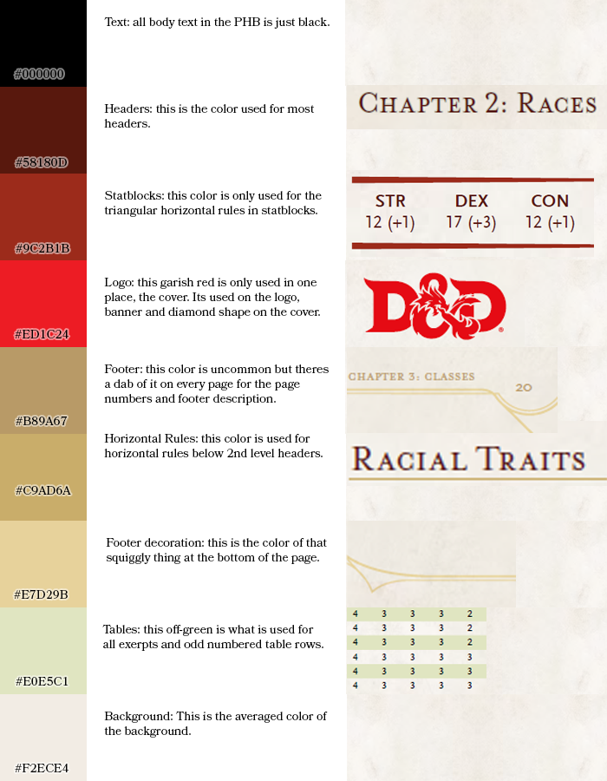

Figure 1

|  |  |  |
| --- | --- | --- |
| Name | Example | Code |
| Heading Color | ⚫ | #53170D |
| Underline | ⚫ | #D2B17D |
| Title Color | ⚫ | #5e0d09 |
| D&D Red | ⚫ | #e92b2f |
| Chapter Title | ⚫ | #620000 |
| Chapter Title Text | ⚫ | #cbd0c5 |
| Quote Block Background | ⚫ | #e4e7e7 |
| Quote Block Border | ⚫ | #8f9b99 |
| Comment Background | ⚫ | #ccd3d3 |
| Comment Border | ⚫ | #231f20 |
| Section Title | ⚫ | #59140a |
| Section Separator | ⚫ | #c8ac6b |
| Bestiary Blue | ⚫ | #D7E5E0 |
| Bestiary Border | ⚫ | #D2B17D |
| Simplified Stat Block Ability Header | ⚫ | #9B3737 |
| Simplified Stat Block Ability Header | ⚫ | #963232 |
| Headers | ⚫ | #58180d |
| Official | ⚫ | #9cdb1b |
| Stat blocks | ⚫ | #ed1c24 |
| Footer | ⚫ | #B89A67 |
| Horizontal line | ⚫ | #c9ad6a |
| Footer Decoration | ⚫ | #e7d29b |
| Tables | ⚫ | #E0e5c1 |
| PHB Background | ⚫ | #F2ECE4 |
| Waterpaper baclgrpimd | ⚫ | #F2F2F2 |
| Laura Red | ⚫ | #DAE6BF |
| Another Red | ⚫ | #953734 |
| Background Green | ⚫ | #CEE4AA |
| Pale Green | ⚫ | #DDF7B6 |
| Purple | ⚫ | #FFB5F0 |
|  | ⚫ | #E8E2D5 |

Theme colors

For this template was created custom color theme with next colors.

|  |  |  |  |
| --- | --- | --- | --- |
| Name | Example | Code |  |
| Dark1 | ⚫ | #000000 |  |
| Light 1 | ⚫ | #FFF2CC |  |
| Dark 2 | ⚫ | #53170D |  |
| Light 2 | ⚫ | #D6EAFE |  |
| Accent 1 | ⚫ | #53170D |  |
| Accent 2 | ⚫ | #D2B17D |  |
| Accent 3 | ⚫ | #CEE4AA |  |
| Accent 4 | ⚫ |  |  |
| Accent 5 | ⚫ | #0563C1 |  |
| Accent 6 |  | #F2F2F2 |  |
| Hyperlink |  |  |  |
| Used Hyperlink |  |  |  |

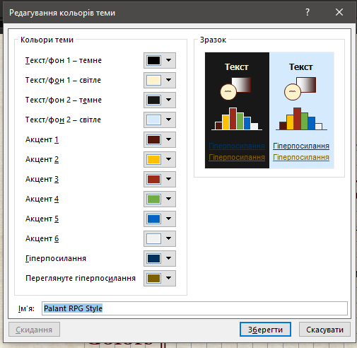

Fonts used

By default, this template uses Cambria and Calibri fonts.

Headings: Cambria

Regular: Calibri

Also this template contains another options which you can use also (but not forget about license of some of those fonts).

Another possible pairs of fonts

|  |  |
| --- | --- |
| Headers | Regular |
| Cambria | Calibri |
| Garamond | Calibri |
|  |  |
|  |  |
|  |  |
|  |  |
|  |  |

SPECIAL FONTS USED

I used in this template a lot of symbolic fonts to create fast visual aid for players and dms.

Rpg Actions

Font Awesome

Rpg Awesome

HEADERS

Now we can talk about Headers and sizes of of it.

Next table contains information about level of used Headers styles and size of its’ fonts for informational purposes.

|  |  |  |
| --- | --- | --- |
| Header Style | Level |  |
| Chapter Title ToC | 1 | 20 |
| Chapter Title | 1 | 20 |
| Subchapter Title | 2 |  |
| Heading 1 ToC | 1 | 18 |
| Heading 2 ToC | 2 | 15 |
| Heading 3 ToC | 3 | 15 |
| Heading 4 ToC | 4 | 10 |
| Heading 5 ToC | 5 | 10 |
| Headline 1 | 0 | 18 |
| Headline 2 | 0 | 15 |
| Headline 3 | 0 | 11 |
| Headline 4 | 0 |  |
| Headline 5 | 0 |  |
| ToC Header |  |  |
| ToC Style 1 | 1 |  |
| ToC Style 2 | 2 |  |
| Toc Style 3 | 3 |  |
| Playtest Heading 1 |  |  |
| DD Title | 1 |  |
| DD Header | 1 |  |
| DD Small Header | 2 |  |
| DD SubHeader | 3 |  |
| Chapter Title | 1 |  |
| Subchapter Title | 2 |  |
| Header | 1 |  |
| Subheader | 2 |  |
| Small Header | 3 |  |

BASIC STYLE LEGEND

Main style used in this template is Basic Text. It was used for creating other styles which names began with word “Basic”

Basic Text

Metadata

Hanging

Indent

* Bulleted

Header

Heading

Parameters of Formatting

Hanging 8 pixels

Hanging 0,33 cm

Intent after 8 px

Color themes

Fonts

Basic Style of Dungeons and Dragons 5e (from PHB)

Headers



Standard color palette of D&D 5e PHB are presented on Figure 1 above.

Color #9C2B1B



#ED1C24 used for RED logo



Footer and horizontal rulers



Tables



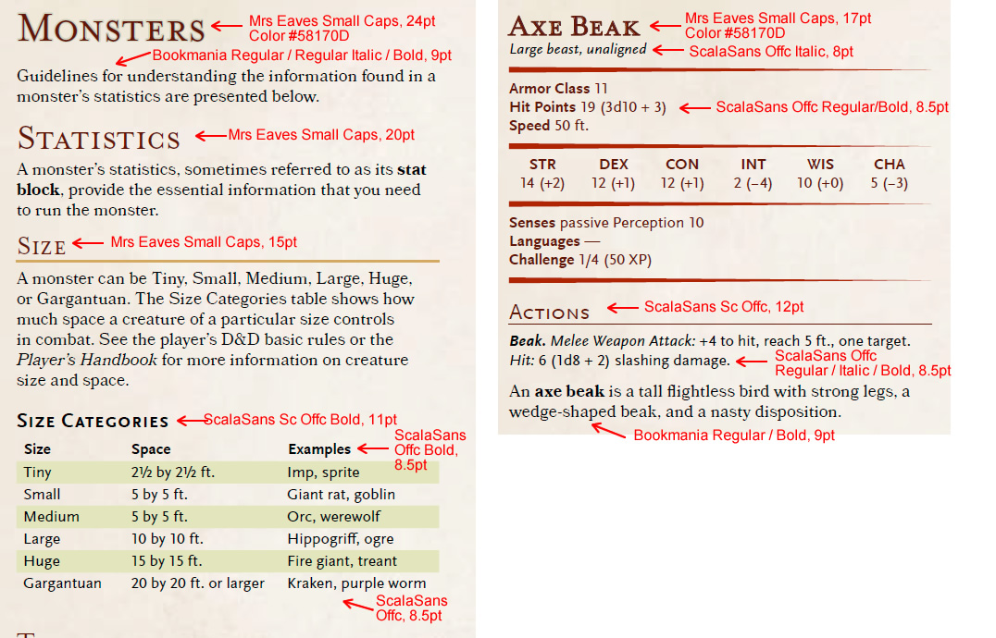

24

20

15

11

8.5



17

12

9

8.5

8

Using this Template

This series of instructions explains how to use the template in a Microsoft Word environment.

Where Do I Put the Template.dotx File?

You need to navigate to this folder by using this path:

Library/Application Support/Microsoft/Office/User Templates/My Templates

Place it in the My Templates folder.

Applying the Template to a New Document

If you’re creating a new document for your RPG, you can do so in three different ways:

The Shortest Way

When you open Word, and if you placed the Template.dotx in your My Templates folder, it should show up as an option. Choose it! You can also click on File in the Menu Bar and choose New from Template.

The Other Way

Alternatively, you could save the template as a .docx file and use that as your starting point.

Applying the Template to an Existing Document

If you need to apply the template to an existing document for D&D Next, you can do the following:

* Open the document.
* Click on Tools in the Menu Bar.
* Click on Templates and Add-Ins in the pull-down menu.
* Click on Attach in the Templates and Add-ins window that pops up.
* Browse to where you placed the template file. My Templates is the default location.
* Click on Template.dotx and Open it.
* Check the box next to Automatically update document styles.
* Click OK.

After you do this, you need to check the file for the following things, and you might need to adjust them manually:

Add in the header and footer. Ensure that the styles are followed. You can do this by copying and pasting the header and footer from a properly styled existing document or by making a .docx file from the .dotx template file.

UNDERSTANDING PURPOSE OF BUILT-IN STYLES

What difference between Header and Heading styles in this template? First is used for naming object of document – table or list, second is used for naming Columns or something else in this object and Text is used for elements of this object.

Using Styles

Open styles gallery

The text formatting in this document relies on Styles. Open the Styles gallery by going to the Home tab, then clicking on the pop-out arrow to open the Styles window:

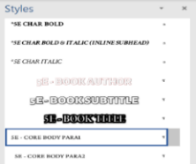

After you do so, a floating Styles box will appear that looks like this. Drag it to the right side of screen to dock it as a sidebar. Very important: Before doing anything else, click on the Options button in the Styles pane and select the following options:

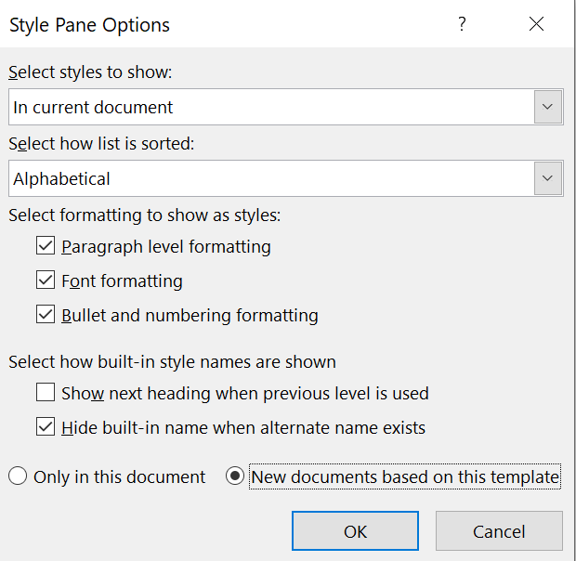

Applying styles

When using this template, do not format things manually, except for when you need to do something that doesn’t have a style (which will happen very rarely). Instead, when you need to change the format of any text, select the style you need from the Styles pane. The later pages of this template contain many examples and instructions for how to select and apply the correct styles to your document.

The thing you’re most likely to need to manually adjust is paragraph spacing, as you might find times you need more space before/after a particular style than the style automatically provides. To do this, go to Paragraph Settings; you may need to change the points before or after a particular paragraph, or to uncheck the box “Don’t add space between paragraphs of the same type.”

Use paragraph styles to bold/italicize

Rather than using the buttons on the ribbon (or Ctrl-B and Ctrl-I) to bold and italicize text, you can assign character styles to do the same. This may seem arduous at first, but has three primary benefits:

• Keeps Word from creating new temporary character styles for every style that you modify by bolding text. If you bold a word without using the “CHAR BOLD” style, Word will start showing a second “CORE BULLETS” style with the bold attribute added… and so on for every single style you add bold or italics to.

• Makes it safer to apply paragraph styles to large blocks of text without worrying about a particular word losing its bolding or italicization. It’ll always keep that character style on it once assigned.

• If you ever send your Word document to a layout designer for professional layout in InDesign, it’s easy for for them to migrate your text over to the final InDesign layout and easily see how words should be formatted.

|  |
| --- |
| Tip: Read the Official Style Guide!  The quick reference above focuses mainly on formatting text. In addition, you should be familiar with the official [D&D House Style Guide](https://www.dmsguild.com/product/267467/DMs-Guild-Creator-Resource--Style-Guide-Resources?affiliate_id=1650578) for fifth edition, freely available on the Dungeon Masters Guild. This contains a wealth of information about how to write for fifth edition. |

Page margins

|  |  |  |
| --- | --- | --- |
| Margin | inches | cm |
| Top | 1” | 2.54 cm |
| Left | 0.8” |  |
| Bottom | 1” | 2.54 cm |
| Right | 0.8” |  |
| Header | 0.4” from the edge | 1.02 cm from the edge |
| Footer | 0.4” from the edge | 1.02 cm from the edge |

You should be aware of the styles that are in place in the document as you go. To see what should be available, in the Styles toolbox, you can use the List functionality to point the list to styles In Current Document to make it easier to see what you need to see. Please delete any styles that are no longer needed in the document; if you try to delete a style that is in use, look for the Select All option before you delete that style. (This option won’t be available if that style isn’t used in the document. Yes, this sounds strange. Welcome to templates.) You can select all instances of that style and change it to the preferred style before you delete the one that is not valid. Be aware that Word 2011 has some quirks still when it comes to deleting styles—sometimes you have to Clear Formatting to truly restyle text. Be mindful of styles as you go.

Columns: Go to Format in the Menu Bar. Choose Columns. Set them to two and give them 0.5” spacing. The Title style should remain as one column; tables might need to flow to one column.

Unformatted Text

The absolute best way to ensure that you have no lingering styles from older documents tainting your new document is to use this process.

WARNING: You will lose italics, bold, and other things that you want to keep, so use this only if you have the time (and preferably dual monitors) to go through and reformat characters as needed. This guarantees that you don’t have to contend with older styles, however, which is also a benefit.

* Copy the text you wish to paste.
* In the destination document, choose Edit in the menu bar and pick Paste Special. (Shortcut: Use Control-Command-V.)
* Choose Unformatted Text when given the option.
* Click OK.
* Compare your original document to the new document and make changes as needed.

If you uses this template correctly, then when you apply an updated template to a document that uses the Template, it will make changes in styles quick and easy to implement

Creating Drop Cap

Y

ou can create a drop cap, like the one at the beginning of this paragraph, by highlighting the paragraph you want to apply it to. Next, click on Insert > Drop Cap > Drop Cap Options, change the font to Rediviva, and change “Lines to Drop” to 5. Finally, highlight the drop cap letter, and change the text color to “Red, Accent 1.” If the paragraph you’re applying it to is italicized, you’ll also have to toggle off the italics for the drop cap.

Using Images

Adding art to your supplement is one of the easiest ways to add polish. Here are some quick tips on how to make the most of Word’s picture tools.

However, keep in mind that putting a lot of images in your Word document will increase your PDF’s file size. You may even experience some slowness while editing the text within Word. Be sure to note the “Compress Images” section on the previous page for instructions on how to reduce your image file size before publishing.

Inserting Art

You can drag and drop art from the Windows File Explorer straight into Word, or click the Insert tab, then click pictures. Once it’s inserted and you click on the image, you’ll see a Picture Format toolbar appear.

Positioning Your Image

For almost all art, you’ll want to change the Wrap Text options to either Tight (wraps text around the shape of that image), Top and Bottom (makes text skip the lines it occupies), but otherwise lets you move it freely), Behind Text (allows you to freely position anywhere, and makes text appear in front of the image), or In Front of Text (allows you to freely position anywhere, and hides text behind it).

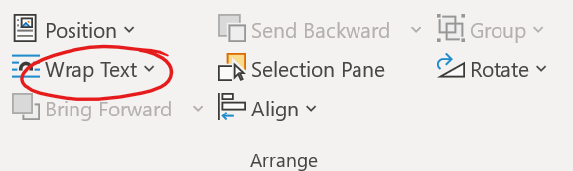

By default, Word tries to restrict your image to keep it within the page margins. To place an image outside them (as with a full-page-width image at the top or bottom of page, as common in official sourcebooks), you can either set it to appear Behind Text (which doesn’t wrap text), or you set it for Top and Bottom wrap, then uncheck the box for Move with Text (which allows you to put it in the margins of your page, but still easily wrap text around it).

Image Effects

While Word isn’t intended for photo manipulation, there are some basic effects it can add to your images. A few of the most useful are demonstrated here, with examples on the right of page.

Picture Styles

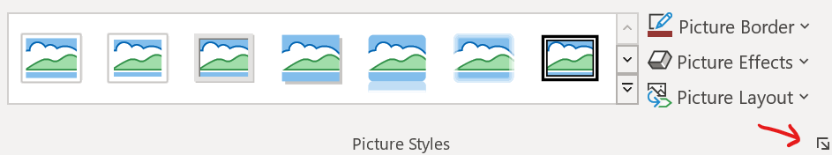You can select a wide range of Picture Styles from a dropdown menu, including frames, drop shadows, and faded edges. In addition, you can customize the styles by opening the Format Picture dialog box (see red arrow for where to click).

Artistic Effects

You can also do some quick “photomanipulation” to add art filters to your pictures, though the options are far more limited than a photo editor like Photoshop (paid) or GIMP (free) would allow.

Picture Styles: Simple Frame

Picture Styles: Drop Shadow: Blur: 10, Distance: 3

Picture Styles: Soft Edge Rectangle

Color: Set Transparent Color



Artistic Effects: Paint Brush

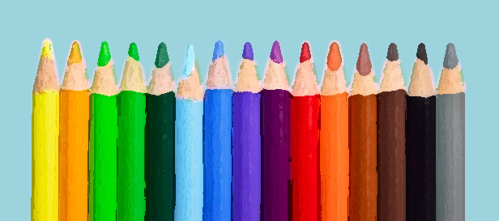

Hotkeys

For styles in this template hotkeys were assigned. In table below you can see all used hot-keyed styles.

|  |  |
| --- | --- |
| Style | Hotkeys |
| Basic Text | Ctrl+A,A |
| Basic Text Paragraph 1 | Ctrl+Q,Q |
| Chapter Title | Ctrl+C,1 |
| Subchapter Title | Ctrl+C,2 |
| Heading 1 TOC | Ctrl+D,D |
| Heading 2 TOC | Ctrl+D,F |
| Heading 3 TOC | Ctrl+D,S |
| Basic Sidebar Heading | Ctrl+S,D |
| Basic Sidebar Text Regular | Ctrl+S,A |
| Basic Sidebar Text Regular Paragraph 2 | Ctrl+S,Q |
| Basuc Table Header | Ctrl+T,F |
| Basuc Table Heading | Ctrl+T,H |
| Basuc Table Heading Centered | Ctrl+T,G |
| Basic Table Text | Ctrl+T,T |
| Basic Table Text Paragraph 2 | Ctrl+T,Q |
| Char Bold | Ctrl+B,B |
| Char Italic | Ctrl+I,I |
| Char Sup | Ctrl+S,U |
| Red Colored | Ctrl+C,R |
| Blue Colored | Ctrl+C,B |
| Green Colored | Ctrl+C,G |
| Boxed Text | Ctrl+B,T |
| Aloud Text | Ctrl+A,T |
| Side Notes | Ctrl+S,T |
| Sidebar |  |
| Sidebar |  |
| Sidebar |  |

Miscellaneous FAQ

This section includes miscellaneous tips and tricks to help you get the most out of this template.

Importing Text With Other Formats

If you copy and paste text into this template from another document, it will likely import with different styles than the ones you need to use. Good news, all of the right template styles start with “5E” to make them easy to find.

You can make changes en masse to other styles that come in with imported text:

Click on a paragraph holding the text you need to reformat—the Styles window will jump to that style.

Hover over that style and click the down arrow next to it.

Click “Select all # Instances.” When you do so, Word will think for a moment, then highlight all the times in the document that use that exact formatting.

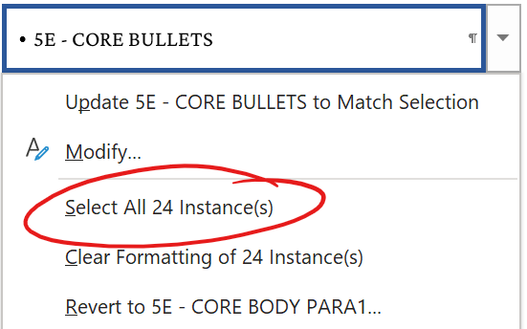With all the text that needs to change highlighted, click on the new style you want to switch it to—for example, the “5E – CORE BODY PARA2” style. Word will switch all that text to using the Core Body style with indented first lines. After that, it’s easy to go through and change the first paragraph of each section to correctly use the “5E – CORE BODY PARA1” style without the indent, while leaving the rest formatted with the proper indent.

How to Un-Italicize Epigraph Text

If you have a style that applies italics (or bold) to a block of text, but you need a portion of it to be formatted without it, you can (counterintuitively) un-italicize it by highlighting that text, then selecting the “*5E CHAR ITALIC” style. This will reverse the italicization on that paragraph. For example, this is useful if you need to un-italicize a word in an italicized epigraph.

Changing Font Size

The core body font size in this template is roughly equivalent to that of a Wizards of the Coast hardcover (even though this font is Merriweather 8 pt., this particular font is larger than Bookmania 9 pt., the font used in hardcovers). If you wish to increase the font size, you can do so by right-clicking on the “5E – CORE BODY PARA1” style and selecting Modify. On the Style Options screen that opens, change the font size dropdown box to 9-point font, then click OK. This will automatically change the Paragraph 2 style as well. You can change other styles (such as sidebar fonts) the same way.

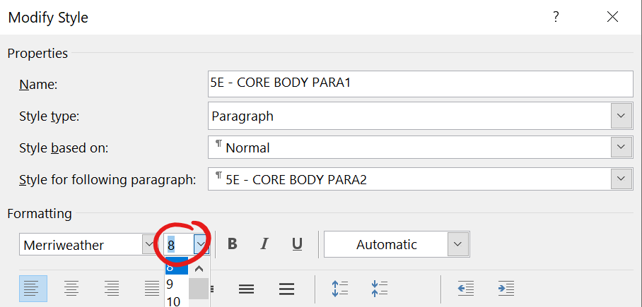

Using on a Mac

This template has been successfully used on Word for Mac, though files created using a Windows computer might appear slightly differently on a Mac, and vice versa. You can use either a Mac or Windows computer for your layout, but it’s not recommended to work on the same file with both systems and expect it to open with the same layout on both—there may be minor shifts in image and text placement.

For best results, install all Office updates before using this on a Mac; to do so, open Word, then on the top menu, click Help > Check for Updates.

Here are the known issues that beta testers have intermittently seen while using Word for Mac:

Hyperlinks and clickable Table of Contents don’t reliably export (this is an overall Word for Mac issue, and not something that this template causes). If your document needs hyperlinks and they don’t export, consider exporting final PDF using a Windows computer; however, be sure the layout hasn’t changed when you switch operating systems!

In some versions of Word for Mac, sidebars have had intermittently distorted text upon PDF export. If this happens, you can try changing sidebar font to Arial.

If you’re using this on a Mac and experience other issues, please [email me](mailto:lhirsb@gmail.com?subject=5E%20Word%20Template%20on%20a%20Mac) and let me know so I can add it to the list (or try to fix it).

Paragraph vs. Character Styles

This template uses both paragraph and character styles. Paragraph styles affect the entire paragraph, and can’t be used to format just part of it. In contrast, character styles allow you to apply selective formatting (e.g. bold) to just a few characters if you wish, while leaving the underlying paragraph style untouched.

You can easily identify which are which in the Styles sidebar: the character styles are prefixed with an asterisk and appear at the top of your style list. You can also identify them by the icon Word displays to the right of that style name. Character styles have an “a” icon, paragraph styles have a “¶” icon.

Slow Performance

Depending on your computer, it may be slow to work with a Word document that has a lot of pictures embedded (as does this sample template). To work around this, don’t add any pictures until you’ve finished writing & layout.

Stat blocks

Statblocks of creatures and NPC are important part of many RPG materials. In this chapter different options to create it are presented – from simple text block to more complex variants.

Simple text block

This statblock uses styles with names StatBlock

Stat Block Title

Stat block metadata

Stat Block Data Take a look at stat blocks in the Monster Manual to see how these styles translate into a finished block. The section below uses the Stat Block Ability Data Name style.

Armor Class AC

Hit Points HP (hit dice)

Speed speed ft.,

STR DEX CON INT WIS CHA

10 (+0) 10 (+0) 10 (+0) 10 (+0) 14 (+2) 11 (+0)

Stat Block Data Notice that there’s no colon after the bold headings in a stat block.

Inline Subhead. Stat Block Regular. The paragraphs below the data section use the Stat Block Regular style.

Actions

Inline Subhead. The Stat Block Heading style above is used for section starts like “Actions” and “Reactions.”

* Stat Block Bulleted. This is the style for a bulleted list in a stat block.
* Stat Block Bulleted. This is the style for a bulleted list in a stat block.

Stat Block Hanging. Use this style for things like spell lists.

Reactions

Stat Block Hanging. Use this style for things like spell lists.

Legendary actions

Stat Block Hanging. Use this style for things like spell lists.

Paragon actions

Stat Block Hanging. Use this style for things like spell lists.

Lair actions

Stat Block Hanging. Use this style for things like spell lists.

Stat Block Modifications

This creature has the following modifications:

* AC 18 (plate armor), and 13 (2d10 + 2) hit points.
* Replace its resistance to cold damage with resistance to fire damage.

Another simple Stat block

Monster Name

Size, type, alignment

AA Stat Block Data Take a look at stat blocks in the Monster Manual to see how these styles translate into a finished block. The section below uses the AA Stat Block Ability Score style.

HP

Speed

STR DEX CON INT WIS CHA

21 (+5) 21 (+5) 21(+6) 21 (+5) 21 (+5) 21(+5)

AA Stat Block Data Notice that there’s no colon after the bold headings in a stat block.

AA Inline Subhead. Stat Block Body. The paragraphs below the data section use the AA Stat Block Body style.

Actions

AA Inline Subhead. The AA Stat Block Heading style above is used for section starts like “Actions” and “Reactions.”

* AA Stat Block Bulleted. This is the style for a bulleted list in a stat block.

AA Stat Block Hanging. Use this style for things like spell lists.

Reactions

Enhanced text block

Stat Block Title

Stat block metadata

Stat Block Data Take a look at stat blocks in the Monster Manual to see how these styles translate into a finished block. The section below uses the Stat Block Ability Data Name style.

Armor Class AC | AC with shield

Hit Points HP (hit dice) max HP

Speed speed ft.,

STR DEX CON INT WIS CHA

10 (+0) 10 (+0) 10 (+0) 10 (+0) 14 (+2) 11 (+0)

Stat Block Data Notice that there’s no colon after the bold headings in a stat block.

Saving Throws STR + 5

Skills Arcana +17, History +17, Insight +11, Perception +11, Persuasion +10

Damage Resistances Fire

Damage Immunities Poison

Condition Immunities Poisoned

Senses Truesight 60 ft., Passive Perception 21

Languages Common, Draconic, Dwarvish, Elvish, Giant, Infernal

Challenge 17 (18,000 XP)

Morale 8

Special Equipment. Laeral wears a white robe of the archmagi (accounted for in her statistics). She wields a flame tongue longsword.

Magic Resistance. While wearing her robe of the archmagi, Laeral has advantage on saving throws against spells and other magical effects.

Spellcasting. Laeral is a 19th-level spellcaster. Her spellcasting ability is Intelligence (spell save DC 21, +13 to hit with spell attacks). Laeral has the following wizard spells prepared:

Cantrips (at will): light, mage hand, minor illusion, prestidigitation, ray of frost

1st level (at will): detect magic, disguise self, magic missile, shield

2nd level (at will): detect thoughts, invisibility, misty step

3rd level (3 slots): counterspell, fly, sending, tongues

4th level (3 slots): banishment, greater invisibility, Otiluke’s resilient sphere

5th level (3 slots): cone of cold, geas, Rary’s telepathic bond

6th level (2 slots): globe of invulnerability, mass suggestion

7th level (1 slot): prismatic spray, teleport

8th level (1 slot): feeblemind, power word stun

9th level (1 slot): time stop

Actions

Inline Subhead. The Stat Block Heading style above is used for section starts like “Actions” and “Reactions.”

* Stat Block Bulleted. This is the style for a bulleted list in a stat block.
* Stat Block Bulleted. This is the style for a bulleted list in a stat block.

Stat Block Hanging. Use this style for things like spell lists.

Reactions

Stat Block Hanging. Use this style for things like spell lists.

Legendary actions

Stat Block Hanging. Use this style for things like spell lists.

Paragon actions

Stat Block Hanging. Use this style for things like spell lists.

Lair actions

Stat Block Hanging. Use this style for things like spell lists.

Stat Block Modifications

Equipment

Tactics

Roleplaying information

Quote

Appearance

Personality Traits

Ideals

Flaws

Bonds

Mannerisms

Expanded Universal Stat Block

Первая часть этого блока статистики представляет собой универсальную версию блока чудовища, но с учетом особенностей игровых персонажей. Во многом подобна краткой нотации персонажей в 3.5 редакции

|  |  |  |  |  |  |  |
| --- | --- | --- | --- | --- | --- | --- |
| Character Name | | | | | | |
| Size race (class level), alignment | | | | | | |
| Armor Class AC  Hit Points HP (hit dice) HP max  Speed speed | | | | | | |
| STR | DEX | CON | INT | | WIS | CHA |
| 10 (+0) | 10 (+0) | 10 (+0) | 10 (+0) | | 10 (+0) | 10 (+0) |
| Skills skills  Saving Throws saves  Damage Vulnerabilities vulnerabilities  Damage Resistances resistances  Damage Immunities immunities  Condition Immunities immunities  Senses senses  Languages languages  Challenge CR (XP) | | | | | | |
| Level 0-30 | | | | Proficiency bonus +0-+10 | | |
| Morale 0 | | | | | | |
| Racial Trait Name. Trait details. | | | | | | |
| Class Feature Name. Feature details. | | | | | | |
| Equipment Details. Equipment details. | | | | | | |
| Actions | | | | | | |
| Action. Details. | | | | | | |
| Bonus actions | | | | | | |
| Bonus action. Details**.** | | | | | | |
| Reactions | | | | | | |
| Reaction. Details**.** | | | | | | |

Вторая часть блока предназначена для более редко используемой информации – снаряжение, тактика, информация по отыгрышу.

|  |
| --- |
| Details |
| Equipment. Details.  Tactics. Details. |
| Roleplaying |
| Description |
| Personality Traits. Details**.** |
| Ideals |
| Flaws |
| Bonds |
| Appearance |
| Mannerisms |

В третьей части блока представлена предыстория персонажа.

|  |
| --- |
| Background |
|  |

Example of filled universal stat block – player character

Example of filled universal stat block – generic NPC

Example of filled universal stat block – standard monster

Simple Table Stat Block

This statblock uses styles with name Monster

|  |  |  |  |  |  |
| --- | --- | --- | --- | --- | --- |
| Monster Name | | | | | |
| Size type, alignment | | | | | |
| Armor Class AC  Hit Points HP (hit dice)  Speed speed | | | | | |
| STR | DEX | CON | INT | WIS | CHA |
| 10 (+0) | 10 (+0) | 10 (+0) | 10 (+0) | 10 (+0) | 10 (+0) |
| Skills skills  Saving Throws saves  Damage Vulnerabilities vulnerabilities  Damage Resistances resistances  Damage Immunities immunities  Condition Immunities immunities  Senses senses  Languages languages  Challenge CR (XP) | | | | | |
| Trait Name. Trait details. | | | | | |
| Actions | | | | | |
| Action. Details. | | | | | |
| Reactions | | | | | |
| Reaction. Details**.** | | | | | |
| Legendary actions | | | | | |
| Action. Details**.** | | | | | |

Enhanced Table Stat Block

This statblock uses styles with name Monster

|  |  |  |  |  |  |
| --- | --- | --- | --- | --- | --- |
| Monster Name | | | | | |
| Size type, alignment | | | | | |
| Armor Class AC  Hit Points HP (hit dice)  Speed speed | | | | | |
| STR | DEX | CON | INT | WIS | CHA |
| 10 (+0) | 10 (+0) | 10 (+0) | 10 (+0) | 10 (+0) | 10 (+0) |
| Skills skills  Saving Throws saves  Damage Vulnerabilities vulnerabilities  Damage Resistances resistances  Damage Immunities immunities  Condition Immunities immunities  Senses senses  Languages languages  Challenge CR (XP) | | | | | |
| Morale 0 | | | | | |
| Trait Name. Trait details. | | | | | |
| Actions | | | | | |
| Action. Details. | | | | | |
| Reactions | | | | | |
| Reaction. Details**.** | | | | | |
| Legendary actions | | | | | |
| Action. Details**.** | | | | | |
| Lair actions | | | | | |
| Action. Details**.** | | | | | |
| Paragon actions | | | | | |
| Action. Details**.** | | | | | |

Enhanced Layout of Monster Stat Block

This statblock uses styles with names Emon*

|  |  |  |  |  |  |  |  |  |  |  |  |
| --- | --- | --- | --- | --- | --- | --- | --- | --- | --- | --- | --- |
| Flaming Fist Battle Wizard | | | | | | | | | | | 6 |
| Medium humanoid (any race), any alignment | | | | | | | | | | | |
| Armor Class: | | | | | 16 | | | | (chain shirt) | | |
| Hit Points | | | | | 45 (10d6+10) max 70 | | | | | | |
| Speed: | 30 f | | | | | | | | | | |
| STR | DEX | | | | | CON | | INT | | WIS | CHA |
| 10(+0) | 16(+3) | | | | | 12(+1) | | 18(+4) | | 12(+1) | 12(+1) |
| Saving Throws: | | | | | | | Con+4, Int +7, Wis +4 | | | | |
| Skills | | Athletics +5, Intimidation +3, Perception +3 | | | | | | | | | |
| Senses | Passive Perception 13 | | | | | | | | | | |
| Languages | | | | Common, and one human regional language or racial language | | | | | | | |
| Challenge | | | 6 (700 XP) | | | | | | | | |
| Special equipment. Battle Wizard carries ring of spell storing, staff of fire, greenstone amulet.  Spellcasting. The Flaming Fist battle wizard is a 9th-level spellcaster. Its spellcasting ability is Intelligence (spell save DC 15, +7 to hit with spell attacks). The battle wizard has the following Wizard spells prepared:  Cantrips (at will): fire bolt, mage hand, shocking grasp, message, green-flame blade  1st level (4 slots): shieldRe, false lifePRE4, burning hands  2nd level (3 slots): flaming sphereCon, misty stepBA  3rd level (3 slots): counterspellRe, fireball, lightning bolt, hasteCon  4th level (3 slots): ice storm, dimension door, stoneskinCon  5th level (1 slot): cone of cold  Staff of Fire (10 charges). Flaming Fist Battle Wizard can cast next spells using staff of fire using Battle Wizard’s spell save DC: burning hands (1 charge), fireball (3 charges), wall of fire (4 charges). The staff regains 1d6+4 expended charges daily at dawn.  Ring of Spell Storing. Battle Wizard can have any spells in his ring of spell storing, but usually he has next spells stored in ring: blur (2nd), flaming sphere (2nd), absorb elementsRe (1st) | | | | | | | | | | | |
| ACTIONS | | | | | | | | | | | |
| Multiattack. Flaming Fist Battle Wizard makes two melee attacks.  AFirebolt. Ranged spell attack: +7 to hit, range 120 ft., one target. Hit: 2d10+4 fire damage | | | | | | | | | | | |
| QShortsword. Melee weapon attack: +6 to hit, reach 5 ft.,one target, Hit: 7(1d6+3) piercing damage. | | | | | | | | | | | |
| REACTIONS | | | | | | | | | | | |
| Arcane Deflection. As reaction Battle Wizard can give himself bonus +4 to AC or +2 to saving throws. In next round after using this ability Battle Wizard can cast only cantrips | | | | | | | | | | | |

false lifePRE4 – precast as 4th level

flaming sphereCon - Concentration spell

misty stepBA - cast as bonus action

counterspellRe – cast as reaction

|  |  |  |  |  |  |  |  |  |  |  |  |
| --- | --- | --- | --- | --- | --- | --- | --- | --- | --- | --- | --- |
| Monster Name | | | | | | | | | | Challenge | |
| Monster Coredata | | | | | | | | | | | |
| Armor Class: | | | | | Off shield 🛡with shield | | | | (description) | | |
| Hit Points | | | | | Average HP (HP formula) max hp | | | | | | |
| Speed: | 30 f | | | | | | | | | | |
| STR | DEX | | | | | CON | | INT | | WIS | CHA | |
| 10(+0) | 16(+3) | | | | | 12(+1) | | 18(+4) | | 12(+1) | 12(+1) | |
| Saving Throws: | | | | | | | Con+4, Int +7, Wis +4 | | | | |
| Skills | | Athletics +5, Intimidation +3, Perception +3 | | | | | | | | | |
| Senses | Passive Perception 13 | | | | | | | | | | |
| Languages | | | | Common, and one human regional language or racial language | | | | | | | |
| Challenge | | | 6 (700 XP) | | | | | | | | |
| Special equipment.  Staff of Fire (10 charges). Flaming Fist Battle Wizard can cast next spells using staff of fire using Battle Wizard’s spell save DC: burning hands (1 charge), fireball (3 charges), wall of fire (4 charges). The staff regains 1d6+4 expended charges daily at dawn.  Ring of Spell Storing. Battle Wizard can have any spells in his ring of spell storing, but usually he has next spells stored in ring: blur (2nd), flaming sphere (2nd), absorb elementsRe (1st) | | | | | | | | | | | |
| ACTIONS | | | | | | | | | | | |
| ASpellattack. Ranged spell attack: +7 to hit, range 120 ft., one target. Hit: 2d10+4 fire damage | | | | | | | | | | | |
| QMelee attack. Melee weapon attack: +6 to hit, reach 5 ft.,one target, Hit: 7(1d6+3) piercing damage. | | | | | | | | | | | |
| rHeavy Crossbow. Ranged Weapon Attack: +3 to hit, range 100/400 ft., one target. Hit: 6 (1d10 + 1) piercing damage.+ AMMUNITION | | | | | | | | | | | |
| REACTIONS | | | | | | | | | | | |
| Arcane Deflection. As reaction Battle Wizard can give himself bonus +4 to AC or +2 to saving thrcows. In next round after using this ability Battle Wizard can cast only cantrips | | | | | | | | | | | |
| **LEGENDARY** ACTIONS | | | | | | | | | | | |
| Arcane Deflection. As reaction Battle Wizard can give himself bonus +4 to AC or +2 to saving throws. In next round after using this ability Battle Wizard can cast only cantrips | | | | | | | | | | | |

Bestiary Stat Block

Single-Column Stat Block Title

Stat block metadata

Armor Class 10

Hit Points 9 (2d8)

Speed 30 ft.

STR DEX CON INT WIS CHA

10 (+0) 10 (+0) 10 (+0) 10 (+0) 14 (+2) 11 (+0)

Saving Throws enter here

Skills enter here

Damage Resistances enter here

Damage Immunities enter here

Condition Immunities enter here

Senses darkvision 60 ft., passive Perception 12

Languages enter here

Challenge 1/4 (50 XP)

Inline Subhead. The inline header has the bold/italic character style, and this paragraph uses the “5E – STAT BLOCK BODY PARA1” style.

Rarely, you may need to have a second paragraph for a particular monster feature; when you do, use the PARA2 style to remove the space before it and add a first-line indent.

Stat Block Heading

Multiattack. This continues using the same stat block body style as in the previous section.

Really Big Stick. Melee Weapon Attack: +9 to hit, reach 10 ft., one target. Hit: 12 (2d6 + 5) bludgeoning damage.

Also two examples of two-column statblock used for really dangerous opponents are presented..

Two-Column Stat Block Title

Stat block metadata

Armor Class 10

Hit Points 9 (2d8)

Speed 30 ft.

STR DEX CON INT WIS CHA

10(+0) 10 (+0) 10 (+0) 10(+0) 14(+2) 11(+0)

Saving Throws enter here

Skills enter here

Damage Resistances enter here

Damage Immunities enter here

Condition Immunities enter here

Senses darkvision 60 ft., passive Perception 12

Languages enter here

Challenge 1/4 (50 XP)

*Inline Subhead.* The inline header has the bold/italic character style, and this paragraph uses the “5E – STAT BLOCK BODY PARA1” style.

Rarely, you may need to have a second paragraph for a particular monster feature; when you do, use the PARA2 style, which removes the space before it and adds a first-line indent.

*Spellcasting.* The creature is a 1st-level spellcaster. Its spellcasting ability is Wisdom (spell save DC 12, +4 to hit with spell attacks). The acolyte has following cleric spells prepared:

Cantrips (at will): light, sacred flame, thaumaturgy

1st level (3 slots): bless, cure wounds, sanctuary

Stat Block Heading

Multiattack. This continues using the same stat block body style as in the previous section.

Really Big Stick. Melee Weapon Attack: +9 to hit, reach 10 ft., one target. Hit: 12 (2d6 + 5) bludgeoning damage.

Another Really Big Stick. Melee Weapon Attack: +9 to hit, reach 10 ft. one target. Hit: 15 (3d6 + 5) bludgeoning damage.

Legendary Actions

Legendary action instructions use “5E – STAT BLOCK BODY PARA1” just as the text in previous section did.

Legendary Action. Be sure to use the “5E – STAT BLOCK HANGING” style for your legendary actions, not the body style. And use the bold character style for each one’s title.

Legendary Action. This is another legendary action.

Legendary Action. This is another legendary action.

Paragon Actions

Roleplaying Info

Some



Имя

*Tiny monstrosity, unaligned (8 pt. font)*



**Armor Class** 12

**Hit Points** 2 (1d4)

**Speed** 10 ft.



|  |  |  |  |  |  |
| --- | --- | --- | --- | --- | --- |
| STR | DEX | CON | INT | WIS | CHA |
| 2 (-4) | 14 (+2) | 11 (+0) | 3 (-4) | 6 (-2) | 5 (-3) |



**Senses** passive Perception 8

**Languages** —

**Challenge** 0 (10 XP)



***Blood Scent.*** The harvester worm is blind, but can sense any source of blood within 120 feet.

Actions

***Bite.***  *Melee Weapon Attack:* +2 to hit, reach 5 ft., one target. *Hit:* 1 piercing damage.

***Resuscitate Dead.*** The harvester worm can use its action to wriggle inside the cranial cavity of a humanoid that has been dead for no longer than 1 day, which it resuscitates. The creature returns to life under control of the harvester worm. The risen creature is known as a Tangle, and has the statistics of a Zombie as detailed in the Monster Manual, pg. 316. If the Tangle dies, the harvester worm survives and may exit its host.

***Harvest Dead.*** While controlling a resuscitated creature, the harvester worm can cause the body to secrete compounds that bond flesh and knit muscle. Over the course of one minute, the harvester worm can incorporate the flesh of a dead humanoid creature into its resuscitated form. This flesh can be used to repair the Tangle or increase its size and strength.

If used to repair itself, the Tangle regains 20 hit points.

If used to increase size and strength, the Tangle’s hit point maximum increases by 15, it deals 3 additional damage with a Slam attack, and its Strength and Constitution scores increase by 1. The harvester worm cannot incorporate more than 4 additional creatures into its form. For each additional creature,

the CR of the Tangle increases by one step. A Tangle that has incorporated 2 or more additional bodies has a Large size.

All examples of statblocks presented in this chapter can be inserted in document created with this template as Building Blocks.

Two-Column Stat Block Title

Stat block metadata

Armor Class 10

Hit Points 9 (2d8)

Speed 30 ft.

STR DEX CON INT WIS CHA

10 (+0) 10 (+0) 10 (+0) 10 (+0) 14 (+2) 11 (+0)

Saving Throws enter here

Skills enter here

Damage Resistances enter here

Damage Immunities enter here

Condition Immunities enter here

Senses darkvision 60 ft., passive Perception 12

Languages enter here

Challenge 1/4 (50 XP)

Inline Subhead. The inline header has the bold/italic character style, and this paragraph uses the “5E – STAT BLOCK BODY PARA1” style.

Rarely, you may need to have a second paragraph for a particular monster feature; when you do, use the PARA2 style, which removes the space before it and adds a first-line indent.

Spellcasting. The creature is a 1st-level spellcaster. Its spellcasting ability is Wisdom (spell save DC 12, +4 to hit with spell attacks). The acolyte has following cleric spells prepared:

Cantrips (at will): light, sacred flame, thaumaturgy

1st level (3 slots): bless, cure wounds, sanctuary

Stat Block Heading

Multiattack. This continues using the same stat block body style as in the previous section.

Really Big Stick. Melee Weapon Attack: +9 to hit, reach 10 ft., one target. Hit: 12 (2d6 + 5) bludgeoning damage.

Another Really Big Stick. Melee Weapon Attack: +9 to hit, reach 10 ft. one target. Hit: 15 (3d6 + 5) bludgeoning damage.

Legendary Actions

Legendary action instructions use “5E – STAT BLOCK BODY PARA1” just as the text in previous section did.

Legendary Action. Be sure to use the “5E – STAT BLOCK HANGING” style for your legendary actions, not the body style. And use the bold character style for each one’s title.

Legendary Action. This is another legendary action.

Legendary Action. This is another legendary action.

Spells templates

Also there are templates for spells and magic items which also can be inserted in document as Building Blocks.

Simple table spell

|  |
| --- |
| Spell Name |
| x-level school |
|  |
| Casting Time: action  Range: x feet  Components: V, S, M  Duration: Concentration, up to x minutes |
|  |
| Spell effects: EFFECTS  At Higher Levels. More powerful spell slots. |
| Classes: Arcane Spellcasters |

Simple text magic item

Boots of the Winterlands

Wondrous item, attunement (requires attunement)

These furred boots are snug and feel quite warm. While you wear them, you gain the following benefits:

* You have resistance to cold damage.
* You ignore difficult terrain created by ice or snow.
* You can tolerate temperatures as low as −50 degrees Fahrenheit without any additional protection. If you wear heavy clothes, you can tolerate temperatures as low as −100 degrees Fahrenheit.

Simple table Magic Item

|  |
| --- |
| Magic Item Name |
| Rarity, power, type, cost, weight, attunement |
|  |
| Description  Properties |

Also we can create fast notes just using Side Notes style

Sidebars samples

In this chapter are many samples of different looking sidebars – you can use anyone in your materials – just choose one which is most suitable for your document.

Side Bar

The body text of any sidebar is always tagged with the **sb2** paragraph style and is always paired with the paper texture behind the text.

A sidebar frame should always have the **Sidebar Box Object Style** applied.

Piciat et laute modi niam

quas ipsunt atempor poriant lat harioressit, sam sequaeperio tecturi busdae non plitetus eicitio-ratem nonsequatus apelitas dolluptatur mag-nam fuga. Epe nobis maximus non restemquo te ea quide nihitem

intionseque molor sandit ducim quas enis apictib usaepti officipsunt, veligni mperehendae nessus mint quae quatust iaerumque excest vol-lessi re del eaque voluptae et quid qui to im none viti aciis doluptati dolupta conet uta dolor re, cus aliquaestrum utemolore odipidi genducia corem

Sidebar

Text

Text

Sidebar

Text

Text

Sidebar

Text

Text

|  |
| --- |
| Different Sidebars |

Sidebar

Text

Text

Sidebar

Text

Text

Sidebar

Text

Text

Piciat et laute modi niam

quas ipsunt atempor poriant lat harioressit, sam sequaeperio tecturi busdae non plitetus eicitio-ratem nonsequatus apelitas dolluptatur mag-nam fuga. Epe nobis maximus non restemquo te ea quide nihitem

intionseque molor sandit ducim quas enis apictib usaepti officipsunt, veligni mperehendae nessus mint quae quatust iaerumque excest vol-lessi re del eaque voluptae et quid qui to im none viti aciis doluptati dolupta conet uta dolor re, cus aliquaestrum utemolore odipidi genducia corem

Sidebar

Text

Text

MM Sidebar - Blue (11 pt. Font)

This is sidebar text, which, along with tables, is in a different font from other text. Align the sides of the sidebar with the text margins of a column. (9 pt. Font)

ЕНУЫе

This is sidebar text, which, along with tables, is in a different font from other text. Align the sides of the sidebar with the text margins of a column. (9 pt. Font)

Sidebar Text (11 pt. Font) - Brown

This is sidebar text, which, along with tables, is in a different font from other text. Align the sides of the sidebar with the text margins of a column. (9 pt. Font)

Sidebar

And some sidebar text!

And more down here!

What the bandits know

The old barn. The bandit’s hideout is roughly half a day to the north west. It is an old barn on an abandoned farm near the old mill.

The bandit leader. The bandits are led by a cruel old man named Donavan. He makes short work of all traitors and is not likely to help the characters.

Sidebar simple text block

And some sidebar text!

And more down here!

Sidebar

Text

Text

Sidebar

Text

Text

Sidebar

Text

Text

Sidebar

Text

Text

Sidebar

Text

Text

TET

Sidebar

Text

Text

Sidebar

Text

Text

Sidebar

Text

Text

Sidebar

Text

Text





|  |
| --- |
| Sidebar  Text  Text |

Sidebar

Text

Text

Sidebar

Sidebar

Text

Text

Sidebar

Text

Text

Sidebar

Text

Text

Sidebar

Text

Text



Sidebar

Text

Text



Sidebar

Text

Text

Tables samples

Also we have samples of tables – simple, styled etc.

Simple tables

PHB Class / Spell List Table - Green

|  |  |  |
| --- | --- | --- |
| Level | Proficiency Bonus | Features |
| 1st | +2 | This class table is used for classes |
| 2nd | +2 | That only need one column of space. |
| 3rd | +2 |  |
| 4th | +2 | #CEE4AA |
| 5th | +3 | #DAE6BF |
| 6th | +3 | CEE4AA |
| 7th | +3 |  |
| 8th | +3 |  |
| 9th | +4 |  |
| 10th | +4 |  |
| 11th | +4 |  |
| 12th | +4 |  |
| 13th | +5 |  |
| 14th | +5 |  |
| 15th | +5 |  |
| 16th | +5 |  |
| 17th | +6 |  |
| 18th | +6 |  |
| 19th | +6 |  |
| 20th | +6 |  |

PHB Class / Spell List Table – Green Style

Even rows – filled #A8D08D

|  |  |
| --- | --- |
| NPC | |
| Manner | Perecab is est |
| Race | Diosant eatet pedis |
| Resistance | Alit volore et ent e |
| Traits | Entdiatem dis |
| Equipment | Saperro et ommolup taquas doluptati |
| Tactics | Vendis earum fugitat emolor |

Table Title – style use

|  |  |
| --- | --- |
| Table Header | Table Header |
| Table Body. InDesign now supports the import of tables, so a table can be used in Word. | Table Body |
| None of the shading here will transfer into InDesign. Only the styles matter. | Table Body |

Styled tables

Tables have styles. The color should match the sidebars.

An Interesting Table Title

|  |  |
| --- | --- |
| First Column | Second Column |
| 1st | First column is centered |
| 2nd | Second column is left-aligned |

|  |  |  |  |  |
| --- | --- | --- | --- | --- |
| d10 | Background Types |  | d10 | Background Types |
| 1 | Ancestral |  | 6 | Elemental |
| 2 | Fey |  | 7 | Undead |
| 3 | Troll |  | 8 | Merman |

|  |  |
| --- | --- |
| d6 | Backgrounds Chart |
| 1 | First column is centered |
| 2 | Second column is left-aligned |

Class Tables

Class Table — Single Column Width

|  |  |  |
| --- | --- | --- |
| Level | Proficiency Bonus | Features |
| 1st | +2 | This class table is used for classes |
| 2nd | +2 | That only need one column of space. |
| 3rd | +2 |  |
| 4th | +2 |  |
| 5th | +3 |  |
| 6th | +3 |  |
| 7th | +3 |  |
| 8th | +3 |  |
| 9th | +4 |  |
| 10th | +4 |  |
| 11th | +4 |  |
| 12th | +4 |  |
| 13th | +5 |  |
| 14th | +5 |  |
| 15th | +5 |  |
| 16th | +5 |  |
| 17th | +6 |  |
| 18th | +6 |  |
| 19th | +6 |  |
| 20th | +6 |  |

Two Side-by-Side Tables—In Text Box

|  |  |  |  |  |
| --- | --- | --- | --- | --- |
| d100 | Result |  | d100 | Result |
| 01-08 | This is a result |  | 59-64 | This is a result |
| 09-13 | This is a result |  | 65-74 | This is a result |
| 14-19 | This is a result |  | 75-78 | This is a result |
| 20-22 | This is a result |  | 79-80 | This is a result |
| 23-27 | This is a result |  | 81-83 | This is a result |
| 28-42 | This is a result |  | 84-85 | This is a result |
| 43-44 | This is a result |  | 86-92 | This is a result |
| 45-53 | This is a result |  | 93-94 | This is a result |
| 54-56 | This is a result |  | 95-96 | This is a result |
| 57-58 | This is a result |  | 97-00 | This is a result |

Tables have styles. The color should match the sidebars.

An Interesting Table Title

|  |  |
| --- | --- |
| First Column | Second Column |
| 1st | First column is centered |
| 2nd | Second column is left-aligned |

|  |  |  |  |  |
| --- | --- | --- | --- | --- |
| d10 | Background Types |  | d10 | Background Types |
| 1 | Ancestral |  | 6 | Elemental |
| 2 | Fey |  | 7 | Undead |
| 3 | Troll |  | 8 | Merman |

|  |  |
| --- | --- |
| d6 | Backgrounds Chart |
| 1 | First column is centered |
| 2 | Second column is left-aligned |

Class Tables

|  |  |  |
| --- | --- | --- |
| Class Table — Single Column Width | | |
| Level | Proficiency Bonus | Features |
| 1st | +2 | This class table is used for classes |
| 2nd | +2 | That only need one column of space. |
| 3rd | +2 |  |
| 4th | +2 |  |
| 5th | +3 |  |
| 6th | +3 |  |
| 7th | +3 |  |
| 8th | +3 |  |
| 9th | +4 |  |
| 10th | +4 |  |
| 11th | +4 |  |
| 12th | +4 |  |
| 13th | +5 |  |
| 14th | +5 |  |
| 15th | +5 |  |
| 16th | +5 |  |
| 17th | +6 |  |
| 18th | +6 |  |
| 19th | +6 |  |
| 20th | +6 |  |

Column-Width Class Table

|  |  |  |
| --- | --- | --- |
| Level | Proficiency Bonus | Features |
| 1st | +2 | Fighting Style, Second Wind |
| 2nd | +2 | Action Surge (one use) |
| 3rd | +2 | Martial Archetype |
| 4th | +2 | Ability Score Improvement |
| 5th | +3 | Extra Attack |
| 6th | +3 | Ability Score Improvement |
| 7th | +3 | Martial Archetype feature |
| 8th | +3 | Ability Score Improvement |
| 9th | +4 | Indomitable (one use) |
| 10th | +4 | Martial Archetype feature |
| 11th | +4 | Extra Attack (2) |
| 12th | +4 | Ability Score Improvement |
| 13th | +5 | Indomitable (two uses) |
| 14th | +5 | Ability Score Improvement |
| 15th | +5 | Martial Archetype feature |
| 16th | +5 | Ability Score Improvement |
| 17th | +6 | Action Surge (two uses) |
| 18th | +6 | Martial Archetype feature |
| 19th | +6 | Ability Score Improvement |
| 20th | +6 | Extra Attack (3) |

Spellcasting

This section is included to show how to format the spellcasting ability lines, as well as bonus spells.

Spellcasting Ability

You can format the below spell save DC and spell attack modifier lines using “5E – CORE SPELLCASTING ABILITY.”

Spell save DC = 8 + your proficiency bonus + your Wisdom modifier

Spell attack modifier = your proficiency bonus + your Wisdom modifier

Bonus Spells

If a subclass grants bonus spells, use the standard table format, which is copied below for ease of use. It’s recommended that you use an inline table, not one floating in a text box, since these should always fall immediately after the bonus spells section.

Sample Spells Table

|  |  |
| --- | --- |
| Class Level | Spells |
| 3rd | spell name, another spell name |
| 5th | spell name, another spell name |
| 7th | spell name, another spell name |
| 9th | spell name, another spell name |

|  |  |  |
| --- | --- | --- |
| Class Table — Single Column Width | | |
| Level | Proficiency Bonus | Features |
| 1st | +2 | This class table is used for classes |
| 2nd | +2 | That only need one column of space. |
| 3rd | +2 |  |
| 4th | +2 |  |
| 5th | +3 |  |
| 6th | +3 |  |
| 7th | +3 |  |
| 8th | +3 |  |
| 9th | +4 |  |
| 10th | +4 |  |
| 11th | +4 |  |
| 12th | +4 |  |
| 13th | +5 |  |
| 14th | +5 |  |
| 15th | +5 |  |
| 16th | +5 |  |
| 17th | +6 |  |
| 18th | +6 |  |
| 19th | +6 |  |
| 20th | +6 |  |

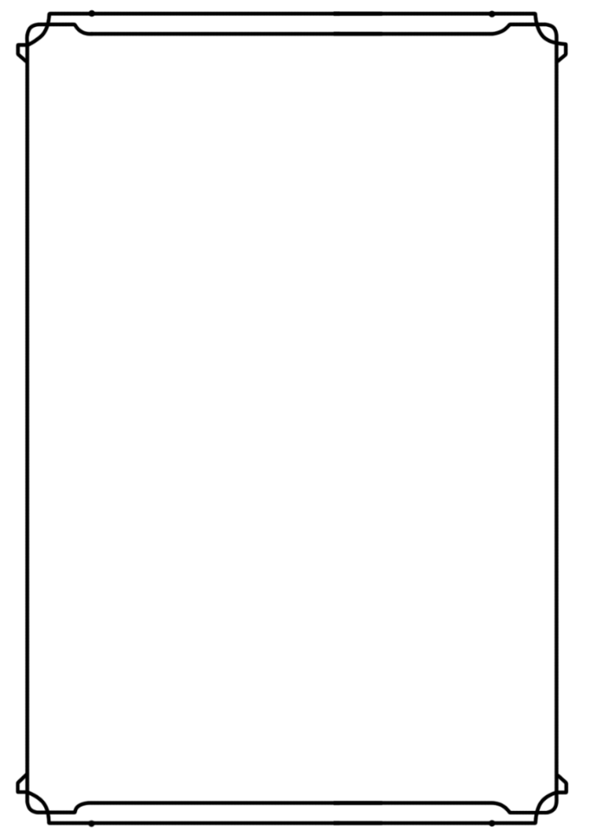

|  |  |  |
| --- | --- | --- |
| **Class Table – Single Column Width** | | |
| Level | Proficiency Bonus | Features |
| 1st | +2 | This class table is used for classes |
| 2nd | +2 | that only need one column of space. |
| 3rd | +2 |  |
| 4th | +2 | You can alter the size of the outline |
| 5th | +3 | by stretching it. |
| 6th | +3 |  |
| 7th | +3 |  |
| 8th | +3 |  |
| 9th | +4 |  |
| 10th | +4 |  |
| 11th | +4 |  |
| 12th | +4 |  |
| 13th | +5 |  |
| 14th | +5 |  |
| 15th | +5 |  |
| 16th | +5 |  |
| 17th | +6 |  |
| 18th | +6 |  |
| 19th | +6 |  |
| 20th | +6 |  |



|  |  |
| --- | --- |
| **DMG Table – Purple** | |
| Column 1 | Column 2 |
| 1 | This table is used in Part 1 of the DMG, which |
| 2 | focuses on the creation of worlds. |
| 3 |  |

|  |  |
| --- | --- |
| DMG Table – Red | |
| Column 1 | Column 2 |
| 1 | This table is used in Part 2 of the DMG, which |
| 2 | focuses on the creation of adventures. |
| 3 |  |

|  |  |
| --- | --- |
| **DMG Table – Gray** | |
| Column 1 | Column 2 |
| 1 | This table is used in the Appendices of the DMG. |
| 2 |  |
| 3 |  |

|  |  |
| --- | --- |
| MM Table – Blue | |
| Column 1 | Column 2 |
| 1 | This table is used in Part 3 of the DMG, which |
| 2 | focuses on running and altering the game. |
| 3 | It is also used in the MM. |

|  |  |
| --- | --- |
| **Scaly Sans Caps Table Title (11 pt.)** | |
| **Scaly Sans** | **Table Interior (9 pt.)** |
| 1st | *bane, ray of sickness* |
| 2nd | *augury, blindness/deafness* |

|  |  |  |  |  |
| --- | --- | --- | --- | --- |
| d10 | Background Types |  | d10 | Background Types |
| 1 | Ancestral |  | 6 | Elemental |
| 2 | Fey |  | 7 | Undead |
| 3 | Troll |  | 8 | Merman |

|  |  |
| --- | --- |
| d6 | Backgrounds Chart |
| 1 | Tradition. The stories, legends, and songs of the past must never be forgotten. (Neutral) |
| 2 | Challenge. Life is worth living when there are obstacles to overcome, problems to face, and changes to adapt to. (Chaotic) |
| 3 | Expertise. True knowledge and application of a skill is a mark of maturity and greatness. (Any) |
| 4 | Order. Through organization, planning, and forethought great success can be achieved – and I have more than enough time for all three. (Lawful) |

Colors used for table fill

|  |  |  |
| --- | --- | --- |
| Color code | Color Name |  |
| #CEE4AA | Green 2 |  |
| #D7E5E0 | Blue | Bestiary |
| #DAE6BF | Green 1 |  |
| #DDDDDD | Grey | GMBook Appendixes |
| #E0E5C1 | Green 3 |  |
| #E6DBEF | Purple | GMBook Worlds |
| #E7D6AF |  |  |
| #F5D3D3 | Red | GMBook Adventure |

|  |  |
| --- | --- |
| **Scaly Sans Caps Table Title (11 pt.)** | |
| **Scaly Sans** | **Table Interior (9 pt.)** |
| 1st | *bane, ray of sickness* |
| 2nd | *augury, blindness/deafness* |

|  |  |  |  |  |  |  |  |
| --- | --- | --- | --- | --- | --- | --- | --- |
| Class Table — Double Column Width | | |  | | | | |
| Level | Proficiency Bonus | Features | Canrips Known | Spells Known | Spell Slots | Slot Level | Invocations Known |
| 1st | +2 | This class table is used for classes |  |  |  |  |  |
| 2nd | +2 | That need two columns of space. |  |  |  |  |  |
| 3rd | +2 |  |  |  |  |  |  |
| 4th | +2 | Delete columns you don’t need on the right, |  |  |  |  |  |
| 5th | +3 | Then select the whole right side and right click, |  |  |  |  |  |
| 6th | +3 | And select “Distribute Columns.” |  |  |  |  |  |
| 7th | +3 |  |  |  |  |  |  |
| 8th | +3 |  |  |  |  |  |  |
| 9th | +4 |  |  |  |  |  |  |
| 10th | +4 |  |  |  |  |  |  |
| 11th | +4 |  |  |  |  |  |  |
| 12th | +4 |  |  |  |  |  |  |
| 13th | +5 |  |  |  |  |  |  |
| 14th | +5 |  |  |  |  |  |  |
| 15th | +5 |  |  |  |  |  |  |
| 16th | +5 |  |  |  |  |  |  |
| 17th | +6 |  |  |  |  |  |  |
| 18th | +6 |  |  |  |  |  |  |
| 19th | +6 |  |  |  |  |  |  |
| 20th | +6 |  |  |  |  |  |  |

Full-Width Class Table

|  |  |  |  |  |  |  |  |  |  |  |  |  |
| --- | --- | --- | --- | --- | --- | --- | --- | --- | --- | --- | --- | --- |
| Level | Proficiency Bonus | Features | Cantrips Known | 1st | 2nd | 3rd | 4th | 5th | 6th | 7th | 8th | 9th |
| 1st | +2 | Druidic, Spellcasting | 2 | 2 | — | — | — | — | — | — | — | — |
| 2nd | +2 | Wild Shape, Druid Circle | 2 | 3 | — | — | — | — | — | — | — | — |
| 3rd | +2 | — | 2 | 4 | 2 | — | — | — | — | — | — | — |
| 4th | +2 | Wild Shape Improvement,  Ability Score Improvement | 3 | 4 | 3 | — | — | — | — | — | — | — |
| 5th | +3 | — | 3 | 4 | 3 | 2 | — | — | — | — | — | — |
| 6th | +3 | Druid Circle feature | 3 | 4 | 3 | 3 | — | — | — | — | — | — |
| 7th | +3 | — | 3 | 4 | 3 | 3 | 1 | — | — | — | — | — |
| 8th | +3 | Wild Shape Improvement,  Ability Score Improvement | 3 | 4 | 3 | 3 | 2 | — | — | — | — | — |
| 9th | +4 | — | 3 | 4 | 3 | 3 | 3 | 1 | — | — | — | — |
| 10th | +4 | Druid Circle feature | 4 | 4 | 3 | 3 | 3 | 2 | — | — | — | — |
| 11th | +4 | — | 4 | 4 | 3 | 3 | 3 | 2 | 1 | — | — | — |
| 12th | +4 | Ability Score Improvement | 4 | 4 | 3 | 3 | 3 | 2 | 1 | — | — | — |
| 13th | +5 | — | 4 | 4 | 3 | 3 | 3 | 2 | 1 | 1 | — | — |
| 14th | +5 | Druid Circle feature | 4 | 4 | 3 | 3 | 3 | 2 | 1 | 1 | — | — |
| 15th | +5 | — | 4 | 4 | 3 | 3 | 3 | 2 | 1 | 1 | 1 | — |
| 16th | +5 | Ability Score Improvement | 4 | 4 | 3 | 3 | 3 | 2 | 1 | 1 | 1 | — |
| 17th | +6 | — | 4 | 4 | 3 | 3 | 3 | 2 | 1 | 1 | 1 | 1 |
| 18th | +6 | Timeless Body, Beast Spells | 4 | 4 | 3 | 3 | 3 | 3 | 1 | 1 | 1 | 1 |
| 19th | +6 | Ability Score Improvement | 4 | 4 | 3 | 3 | 3 | 3 | 2 | 1 | 1 | 1 |
| 20th | +6 | Archdruid | 4 | 4 | 3 | 3 | 3 | 3 | 2 | 2 | 1 | 1 |

Sample List

|  |  |
| --- | --- |
| List Title  List item  List item  List Title  List item  List item | List Title  List item  List item  List Title  List item  List item  List item |

Other Blocks

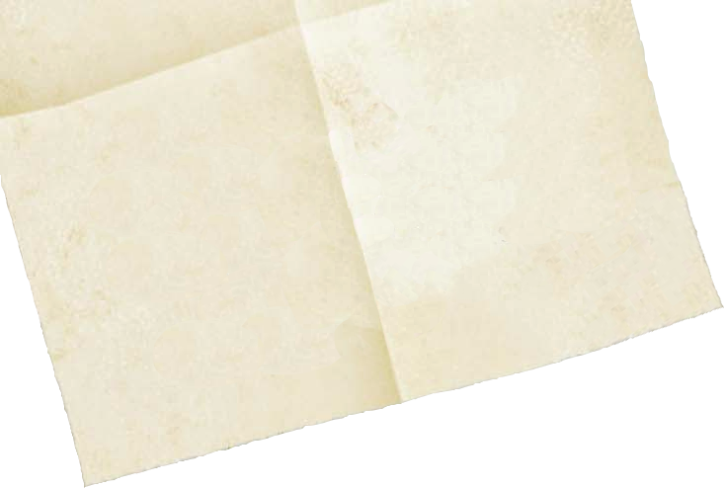

Flavor Text!

…

…

…

…

…

…



Flavor Text!

…

…

…



Chapter 1. Test

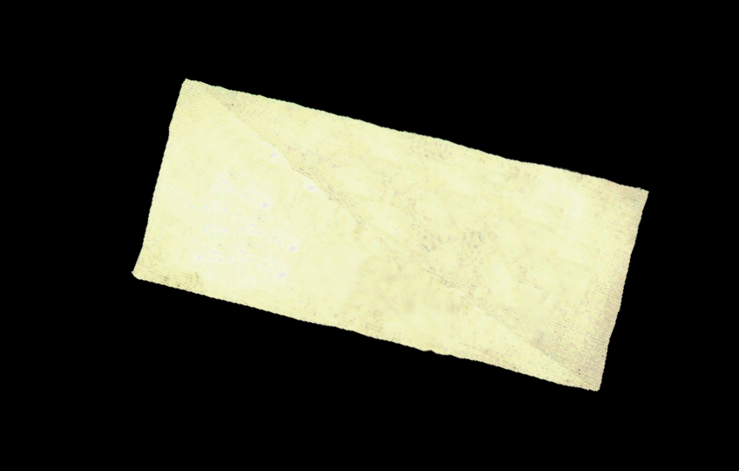

Flavor Text!

…

…

…

…

 



Dungeons & Dragons License

DUNGEONS & DRAGONS, D&D, Wizards of the Coast, Forgotten Realms, the dragon ampersand, Player’s Handbook, Monster Manual, Dungeon Master’s Guide, D&D Adventurers League, all other Wizards of the Coast product names, and their respective logos are trademarks of Wizards of the Coast in the USA and other countries. All characters and their distinctive likenesses are property of Wizards of the Coast. This material is protected under the copyright laws of the United States of America. Any reproduction or unauthorized use of the material or artwork contained herein is prohibited without the express written permission of Wizards of the Coast.

copyright 2016 Wizards of the Coast LLC, PO Box 707, Renton, WA 98057-0707, USA. Manufactured by Hasbro SA, Rue Emile-Boéchat 31, 2800 Delémont, CH. Represented by Hasbro Europe, 4 The Square, Stockley Park, Uxbridge, Middlesex, UB11 1ET, UK.

Author Copyright

All other original material in this work is copyright 2020 by Author and published under the Community Content Agreement for Dungeon Masters Guild.

Двуязычность

Boxed set can also be useful

В этом шаблоне работают и русский и английский языки, поскольку базовые шрифты подбирались исходя из наличия и кириллических и латинских символов, что выгодно его отличает от других шаблонов, которые доступны для покупки на DMSGUILD и DRIVETHRURPG

Заголовок 2

Полужирный курсив

Заголовк 3

Файл предназначен для широкого круга пользователей – в первую очередь для переводчиков

X🛡Y – NPC has AC Y with equipped shield, without it NPC has AC X.

+ X something – number of ammunition

Playtest example

Playtest heading 2

Playtest heading 3

Playtest warning.

Monster Name

USEFUL LINKS

DMSGUILD.COM

1. [InDesign Templates and Beginner's Guide](https://www.dmsguild.com/product/249157/InDesign-Templates-and-Beginners-Guide?affiliate_id=759617) by [Nathanael Roux](https://www.dmsguild.com/browse.php?author=Nathana%C3%ABl%20Roux)
2. [Simple 5E Microsoft Word Template & Beginner's Guide](https://www.dmsguild.com/product/311458/Simple-5E-Microsoft-Word-Template--Beginners-Guide?affiliate_id=759617) by [Laura Hirsbrunner](https://www.dmsguild.com/browse.php?author=Laura%20Hirsbrunner)

Microsoft Word links

1. [ABOUT STYLES](https://guides.lib.umich.edu/c.php?g=283073&p=1886003)
2. [Use Quick Parts and AutoText in Word](https://support.microsoft.com/en-us/office/use-quick-parts-and-autotext-in-word-7a527697-058f-4967-b8f1-aae0774e4813?ui=en-us&rs=en-us&ad=us) [Quick Parts](https://support.microsoft.com/en-us/office/quick-parts-4ffef7c5-7596-4e95-9faf-41c771847a7b#bm4) ABOUT [Using Building Blocks in Word](https://versitas.com/blog/using-building-blocks-word/)
3. [Building Blocks in Word](https://versitas.com/blog/building-blocks-word/)
4. [Change a theme and make it the default in Word or Excel](https://support.office.com/en-us/article/change-a-theme-and-make-it-the-default-in-word-or-excel-c846f997-968e-4daa-b2d4-42bd2afef904)
5. [Create my own color theme](https://support.office.com/en-us/article/change-a-theme-and-make-it-the-default-in-word-or-excel-c846f997-968e-4daa-b2d4-42bd2afef904#bkmk_create)
6. [Change theme effects](https://support.office.com/en-us/article/change-a-theme-and-make-it-the-default-in-word-or-excel-c846f997-968e-4daa-b2d4-42bd2afef904#_effects)
7. [Change the theme fonts](https://support.microsoft.com/en-us/office/apply-themes-55922445-1629-4a9f-ae63-1e2c1f295fdf)
8. [Change a theme and make it the default in Word or Excel](https://support.microsoft.com/en-us/office/change-a-theme-and-make-it-the-default-in-word-or-excel-c846f997-968e-4daa-b2d4-42bd2afef904)
9. [10 Microsoft Word Style Secrets](https://www.pcworld.com/article/260668/10_microsoft_word_style_secrets.html)

FONTS

[Rosario](https://www.1001fonts.com/rosario-font.html)

[Crimson Roman](https://www.1001fonts.com/crimson-font.html)

[Vollkorn](https://www.1001fonts.com/vollkorn-font.html)

[Andada](https://www.1001fonts.com/andada-font.html)

[Merriweather](https://www.1001fonts.com/merriweather-font.html)

[Merriweather sans](https://www.1001fonts.com/merriweather-sans-font.html)

[Lora](https://www.1001fonts.com/lora-font.html)

[Varela Round](https://www.1001fonts.com/varela-round-font.html)

Commercial [Mrs Eaves Small Caps](https://www.myfonts.com/fonts/emigre/mrs-eaves-ot/?refby=1001fonts)

Also: [a lot of handwritten fonts](https://www.1001fonts.com/informal-fonts.html)

[Trickster Font](https://www.1001fonts.com/trickster-font.html)

Free for personal use [Enchanted Land Font](https://www.1001fonts.com/cup-and-talon-font.html)

Free for personal use [Cup and Talon Font](https://www.1001fonts.com/enchanted-land-font.html)

Free for personal use [seven swordsman](https://www.1001fonts.com/seven-swordsmen-bb-font.html)

CHANGELOG

07.06.2020 – Version 0.2 Initial Release

09.07.2020 – Version 0.22 Styles minor edit.

22.07.2020 – Version 0.3. Added styles, rework, added blocks, added hotkeys

To-do

Description of Quick Parts

Description of Color Theme

Description of Using Styles

Description of Font Themes

Examples of Styled Tables

Examples of Styled Statblocks

Useful links on dmsguild.com to Art for page layouts

How-to create simple handouts

How-to create simple sidebars

More color themes

Simplified similar to Adventurers League Black & White Template

Backcover page

Cover page

ABOUT COLORS CODES

[COLORS HEX RGB TABLE.xlsx](https://1drv.ms/x/s!Atcrhwwo1lBAyss0i59Og5LJQlERTA?e=KaoF1T)

LEGAL







Palant Word Template